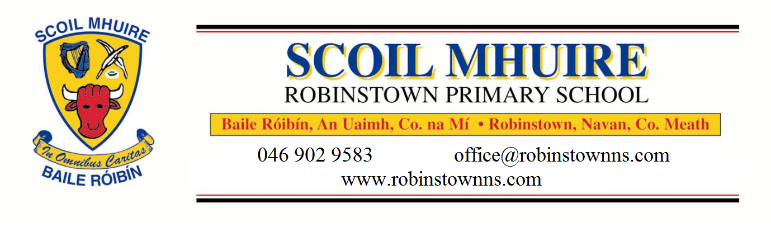
REGISTRATION FORM 2026/2027
Uimhir Rolla: 17520 U
We require your child’s Birth Certificate along with this form.
If your child was baptised outside of Robinstown Parish we require a copy of the Baptismal Certificate.

Please complete in BLOCK CAPITALS  Year Starting School: |  | Please tick CLASS: Preschool ASD Unit:  Junior Senior 1st  2nd 3rd 4th  5th 6th
Pupil's Name: |  | Name in Irish:  (Optional)
Date of Birth: |  | Male/Female
P.P.S. Number: |  | Country of Birth:
Address: |  | Nationality:
 |  | If born outside the country, year of arrival in Ireland:
Eircode: |  | Languages spoken in the home:
Parent/Guardian Details |  | Parent/Guardian Details
First Name: |  | First Name:
Last Name: |  | Last Name:
Relationship to child: |  | Relationship to child:
Phone No (Home): |  | Phone No (Home):
Phone No (Work): |  | Phone No (Work):
Phone No (Mobile): |  | Phone No (Mobile):
email Address: |  | email Address:
Names of brothers/sisters in this school:

It is school policy to pass on the above information excepting Religion and Ethnicity to the Department of Education and Skills.
Have you applied to another school, please give details:

Please tick |  |  | Yes | No
Are there any orders or other arrangements in place governing access to or custody of your child?

The school may share Personal Pupil Data with other organisations such as HSE, Tusla, An Garda Síochána, etc where there is a legal basis for doing so under GDPR.
Name of Previous School/Pre-school:
Address:
Principal's Name: Phone No:
Additional local contact names, to be contacted in emergencies [Not the same as above]
Name: |  | Phone No:
Relationship to child:
Name: |  | Phone No:
Relationship to child:
Name: |  | Phone No:
Relationship to child:
SCHOOL USE ONLY

If the language spoken at home is NOT English, an Appointment with our E.A.L. (English as Another Language) teacher is required.

Date of Appointment: _______________________________ Time: _______________________

Teacher: ________________________________

Relevant Medical Information:
Family Doctor: | Phone No:
Any medical concern/information of relevance? (use a separate sheet, if required)

Has your child any Special Educational Needs? Details:

Consent Form

We would like your permission for the following in relation to your child
Please tick the appropriate box and sign - Both parents/guardians please sign below

Please Tick | Yes | No
Activities Outside/After School
During the school year classes may undertake activities outside the school premises e.g. visiting the church, library. I consent that my child may do so.
Do you consent for your child to participate in school trips? For example, walks, school tours, matches, concerts, etc.
D.T. (Digital Technology)
Do you consent for your child to access the internet in accordance with our Comprehensive ‘Internet Access and Accessible Usage Policy’ (available from the school website)?
Do you consent to the Schools Data procedures?– The information in this form is necessary for the work of the school and is confidential to the School. The school has data protection and record keeping policy that identifies how personal information held by the school is securely stored. In compliance with legislation, the school may be asked to provide information to the Department of Education & Science, Child & Family Agency or to the HSE to facilitate their work. Please tick yes if you consent in this information being shared with the agencies listed above.
Do you consent to the creating and maintaining of a Google for Education Account for your child for educational purposes?
Do you consent to the creating and maintaining of a Seesaw Account for your child for educational purposes?
School Website/Publications: I give consent for the use of school related photographic images which include my son/daughter on the school website or in other school publications or displays. I understand that s/he will not be identified individually.
Do you consent for your child’s work to be put on our website e.g. photo’s /videos of your child, their work, pictures, poems, stories etc. (No names will be used)
Do you consent for your child’s photograph to be placed on the school website?
(No names will be used with photographs on the website)
Do you consent for your child’s photograph to be shared with a newspaper in the event of a newspaper featuring news from our school?
Medical Emergencies
I give permission for my child to receive any medical attention deemed necessary and to be taken to hospital in case of serious illness or accident.
Do you consent to your child’s uniform being changed by a teacher in the presence of another adult in case of illness or toilet accident ?
School Policies
I agree to the terms of Robinstown NS’s Code of Behaviour and ensure that my child and I will abide by it. This policy is available on our school website www.robinstownns.com
I agree to familiarise myself with all school policies, agree to abide by them and agree to discuss them at an appropriate level with my child.
Do you consent to your child’s participation in the RSE programme?

Do you consent to your child’s participation in the Stay Safe programme?

Do you consent to your child’s participation in Screening Tests which are carried out in the school on all children from Infants to 6th class?

Do you consent for teachers to carry out diagnostic tests on your child, if deemed necessary in order to help them in their educational development?
Do you consent to the use of your mobile number by the school for text a parent updates, eg. Reminder about staff meetings or holidays, etc.?
Competitions
I give consent to allow my child to enter school competitions and for their name and date of birth to be shared with the organisers.

Any other relevant information about your child: _____________________________
____________________________________________________________________
During the year opportunities arise for parents to volunteer to help around the school. If you have any particular skill that you would be able to volunteer to the school please let us know here: e.g. computer skills, manual labour, knitting, plumbing, gardening, needlework, cooking, electrical work, music skills etc
________________________________________________________________________
I / We confirm the above details are correct.

I/we wish to enrol my/our child in Robinstown National School
Signed: Parent/Guardian Date:
Signed: Parent/Guardian Date:
Both Parents/Guardians to sign

Department of Education Primary Online Database

Birth Cert Forename: __________________________ Birth Cert Surname: _________________________
PPSN of Pupil: _______________________ Mother’s Maiden Name: _____________________________
The Department of Education and Skills is developing an electronic database of primary school pupils called the Primary Online Database (POD) which will involve schools maintaining and returning data on pupils to the Department at individual pupil level on a live system. The database will allow the Department to evaluate progress and outcomes of pupils at primary level, to validate school enrolment returns for grant payment and teacher allocation purposes, to follow up on pupils who do not make the transfer from primary to post primary level and for statistical reporting. The database will hold data on all primary school pupils including their PPSN, First Name, Surname, Name as per Birth Certificate, Mother's Maiden Name, Address, Date of Birth, Gender, Nationality, whether one of the pupil's mother tongues is English or Irish, whether the pupil is in receipt of an Exemption from Irish and if so the reason for same, whether the pupil is in receipt of Learning Support and if so the type of learning support, whether the pupil is in a Mainstream or Special Class. The database will record the class grouping and standard the pupil is enrolled in. The database will also contain, on an optional basis, information on the pupil's religion and on their ethnic or cultural background.

The Department has consulted with the Data Protection Commissioner in relation to the collection of individual pupil information for the Primary Online Database. Both religion and ethnic and cultural background are considered sensitive personal data categories under Data Protection legislation. Therefore, it is necessary for each pupil’s parent/guardian to identify their child’s religion and ethnic background, and to consent for this information to be transferred to the Department of Education and Skills. All other information held on POD was deemed by the Data Protection Commissioner as non-sensitive personal data.
To which ethnic or cultural background group does your child belong (please tick one)? (Categories are taken from the Census of Population)
Please Tick
White Irish
Irish Traveller
Roma
Any other White Background
Black African
Any other Black Background
Chinese
Any other Asian background
Other (inc. mixed background)
No consent

What is your child’s religion?
Roman Catholic
Church of Ireland
Presbyterian
(incl. Protestant)
Methodist, Wesleyan
Jewish
Muslim (Islamic)
Orthodox
(Greek, Coptic, Russian)
Apostolic or Pentecostal
Hindu
Buddhist
Jehovah's Witness
Lutheran
Atheist
Baptist
Agnostic
Other Religions
No Religion
No Consent

I consent for this information to be stored on the Primary Online Database (POD) and transferred to the Department of Education and Skills and any other primary schools my child may transfer to during the course of their time in primary school.

Signed: ___________________________ Date: ____________________________
Parent/Guardian

